Exercise N° 1: Answer the following questions (5pts)

- Differentiate between Southern blotting, Northern blotting, and Western blotting in terms of the type of molecule detected.? (0.75)
- Southern blotting: DNA detection 0.25
- Northern blotting: RNA detection 0.25
- Western blotting: Protein detection 0.25
- What are the main steps of Northern blotting technique? (01)
Extraction of mRNA
Denaturation of RNA
Gel electrophoresis (denaturing agarose gel)
Transfer to nylon/nitrocellulose membrane
Hybridization with labeled probe
Detection by autoradiography

- List the main advantages of PCR technology (01)
Highly specific 0.25
Sensitive 0.25
Versatile 0.25
Rapid and efficient 0.25

- What are the main symptoms of salmonellosis? (0.5)
Nausea,vomiting, abdominal cramps, diarrhea, fever, muscle aches.

5. The main toxins of Shigella (1.75)
Shiga Toxin (Stx) 0.25
Endotoxin 0.25 (LPS - Lipopolysaccharide) 0.25
Cytotoxic Effectors 0.25 (IpaB, IpaC, IpaD) 0.25
Enterotoxins 0.25 (ShET-1 and ShET-2) 0.25

Exercise N°2. Indicate whether the following statements are True or False. Correct the false statements (5pts)

Southern blot is used to detect RNA. (1.5)

False 0.25 → Southern blot is used to detect DNA. 1.25

Foodborne viruses multiply in food. (1.5)
False 0.25 → Viruses do not multiply in food; they use it as a vehicle. 1.25

Antibodies involved in agglutination reactions are called agglutinates (1.5)
False 0.25 →Antibodies involved in agglutination reactions are called agglutinins 1.25

Clostridium species can produce spores that survive harsh conditions.(0.25)
True…0.25…

PCR is used to amplify specific DNA sequences. (0.25)

True…0.25
Exercise N°3. Choose only One correct answer (5pts)

1. Which enzyme is used in PCR reaction? (01)
A. RNA polymerase
B. Taq DNA polymerase
C. Ligase
D. Protease
2. Which of the following is a toxigenic bacterium? (01)
A. Salmonella
B. Shigella
C. Staphylococcus aureus
D. Campylobacter
3. Invasive pathogenic germs act by: (01)
A. Producing toxins in food
B. Penetrating and multiplying in the intestinal mucosa
C. Remaining inactive in the intestine
D. Producing spores only
4. In Southern blot, the target molecule is: (01)
A. RNA
B. Protein
C. DNA
D. Lipids
5. Rose Bengal test is mainly used for the diagnosis of: (01)
A. Tuberculosis
B. Salmonellosis
C. Campylobacteriosis
D. Brucellosis

Exercise N°4. The diagram below represents components of the PCR Master Mix. Label its components (5pts)
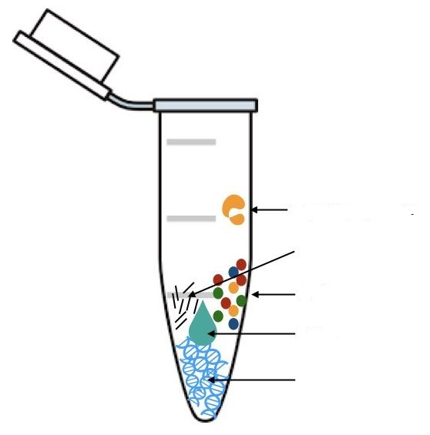
1…Taq DNA polymerase (01)
2…Mg²⁺ ions…………… (01)
3…dNTPs………….…… (01)
1
4…Buffer Solution……… (01)
5…DNA………………… (01)
3
2
4
5

