Analysis and Modeling of a high Speed ULB Micro-Ruban Antenna for Wireless Applications by the 3D FDTD method with PML
Aichetou Mohameden¹, Yassine Beddiaf^{2,} Badra Sami²
¹Faculty of technology, Al-Aasriya university, Nouakchott, Mauritania
²Departùent of industrial engineering, University of Khenchela, Algeria

Abstract - In recent years, planar antennas have experienced enormous progress due to their numerous uses, consequently, several research works addressing this type of antennas have been published. In this context we propose a new antenna configuration consists of an $18×18 mm$ ring-shaped square micro-ribbon patch with two $1×0.5 mm$ rectangular slots on the patch and a $35×6×1.6 mm$partial ground plane with two rectangular slots. This antenna was simulated with HFSS software, and Analyzer with rigorous 3D-FDTD analytical method with PML. The operating frequency bands of the printed monopole antenna cover the FCC band. The results of analysis of this antenna by 3D FDTD with PML are compared with the HFSS simulation. The simulation results obtained are acceptable and show the feasibility of our proposed antenna.

Keywords - PML ,FDTD 3D ,Micro-ribbon square antenna, ultra-wide band antenna, ULB, partial ground plane, annular shape, rectangle-shaped slot, notch

- Introduction
Indeed, the preferred areas of use for microstrip antennas are high frequency communications such as space communications, military systems; GPS satellite positioning, air navigation. or land navigation, wireless computer networks WLAN (Wireless Local Area Network), new fields such as medicine (MRI, etc.) and mobile telephones. This wide and important use of these antennas is essentially due to the various advantages they can offer compared to conventional antennas, such as : low weight, very low manufacturing cost, production in easy series.
Several methods and models are proposed to analyze microstrip antennas. The FDTD method, thanks to its simplicity of implementation and its robustness, has achieved real popularity since its introduction in the electromagnetic community. This temporal and volume method is based on solving Maxwell's equations in their local form (differential form). Its use involves the creation of a volume encompassing the antennas and the platform, then the mesh via elementary cells whose size is fixed by the highest excitation frequency. One of the main limitations of FDTD for simulating antennas on a platform is linked to its very high numerical cost. As the study frequency increases, the number of elementary cells increases drastically. However, with FDTD, it is very easy to take advantage of highly parallel computer resources. Thus, algorithms exploiting parallelization’s have recently been applied to the FDTD in order to simulate the coupling and the radiation of antennas positioned on a ship or an airliner [1][2][3].
In this article we use Open EMS which is a free and open source FDTD solver written in C ++. An open EMS support cylindrical coordinates and is specially developed for MRI applications. An extended Matlab (or Octave) interface is used to define FDTD options. The geometry used for FDTD simulations is managed by the CSXCAD library which is part of the open EMS project [5][6].
- Principle of the FDTD method
Electromagnetism is a notion that links electric and magnetic fields varying over time in inseparable quantities. However, until the middle of the 19th century, scientists recognized that electric and magnetic fields were independent of each other. Then, as electricity and magnetism began to be studied in depth, Ampere's and Faraday's laws were the first to relate strictly to the motion of two physical quantities [7-27]. After the unification of contemporary understanding of electromagnetism achieved by James Clerk Maxwell, he proposed a set of 20 differential equations with 20 variables connecting all electrical and magnetic components. Finally, by applying vector notation, all of these formulas were reduced to the following elegant set of 5 vector differential equations with 5 vector quantities [7-27].
$\vec{∇}∧\vec{H}=ε_{0}\frac{∂E}{∂t}+J$ (1)
$\vec{∇}∧\vec{E}={-μ}_{0}\frac{∂H}{∂t}$ (2)
$\vec{∇}⋅ \vec{B}=0$ (3)
$\vec{∇}⋅ \vec{D}=ρ$ (4) $\vec{∇}⋅ \vec{E}=-\frac{∂ρ}{∂t}$ (5)
H - magnetic field, E - electric field, J - density of electric current, B - density of magnetic flux, D - density of electric flux, ρ - density of electric charge, ε0 - permittivity in free space, µ 0 - permeability in free space. The time-dependent Maxwell's curve equations (1,2) were incorporated into a finite difference scheme created by Kane Yee in 1966 [7-27]. The special arrangement of the components of electric and magnetic fields proposed by Yee is commonly referred to as the Yee cell (see Figure 1).Such a distribution of electromagnetic (EM) components makes it possible to solve Maxwell's equations in the following discretized form, with second order precision [7].
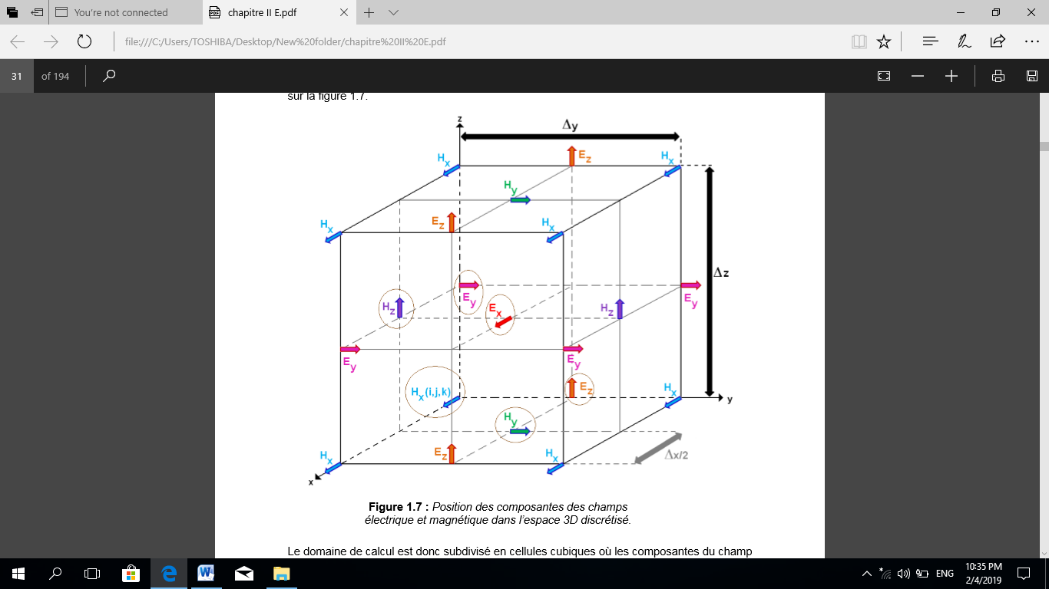 Fig.1 Yee’s Cells
Update equations without PML media:
$H_{xy}^{n+\frac{1}{2}}\left(i,j,k\right)=e^{\frac{σ_{y\left(i,j,k\right)∆t}^{*}}{μ_{0}}}H_{xy}^{n-\frac{1}{2}}\left(i,j,k\right)∙\frac{∆t}{μ_{0}∆}\left\{E_{tx}^{n}\right.\left(i,j,k\right) -E_{zx}^{n}(i,j-\frac{1}{2} ,k)∙E_{zy}^{n}(i,j-\frac{1}{2} ,k)\}$ (6)
$E_{xy}^{n}\left(i+\frac{1}{2},j+\frac{1}{2} ,k+\frac{1}{2}\right)≅$
$E_{xy}^{n+\frac{1}{2}}(i+\frac{1}{2},j+\frac{1}{2},k+\frac{1}{2})$ (7)
$J_{pxy,m}^{n+\frac{1}{2}}\left(i+\frac{1}{2},j+\frac{1}{2},k+\frac{1}{2}\right)=e^{{-Γ}_{m}Δt}J_{pxy,m}^{n-\frac{1}{2}}\left(i+\frac{1}{2},j+\frac{1}{2} ,k+\frac{1}{2}\right)+Δt[f_{m}Ω_{p}^{2}E_{xy}\left(i+\frac{1}{2},j+\frac{1}{2} ,k+\frac{1}{2}\right)-w_{m}^{2}p_{xy,m}^{n}(i+\frac{1}{2},j+\frac{1}{2},k+\frac{1}{2})$ (8)
$p_{xy,m}^{n+1}\left(i+\frac{1}{2},j+\frac{1}{2},k+\frac{1}{2}\right)=p_{xy,m}^{n}\left(i+\frac{1}{2},j+\frac{1}{2},k+\frac{1}{2}\right)+∆t J_{pxy,m}^{n+\frac{1}{2}}(i+\frac{1}{2},j+\frac{1}{2},k+\frac{1}{2})$ (9)
The stability condition of the FDTD algorithm is [7-27] : $r≥\sqrt{3}$
Of which
$r=\frac{1}{CΔt}\sqrt{\frac{3}{Δx^{-2}+Δy^{-2}+Δz^{-2}}}$
Update equations in PML media:
$$H_{xy}^{n+\frac{1}{2}}\left(i,j,k\right)=e^{\frac{σ_{y\left(i,j,k\right)∆t}^{*}}{μ_{0}}}H_{xy}^{n-\frac{1}{2}}\left(i,j,k\right)∙\frac{∆t}{μ_{0}∆}\left\{E_{tx}^{n}\right.\left(i,j,k\right)$$
-$E_{zx}^{n}(i,j-\frac{1}{2} ,k)∙E_{zy}^{n}(i,j-\frac{1}{2} ,k)\}$ (10)
$$E_{xy}^{n}\left(i+\frac{1}{2},j+\frac{1}{2} ,k+\frac{1}{2}\right)≅$$
$E_{xy}^{n+\frac{1}{2}}(i+\frac{1}{2},j+\frac{1}{2},k+\frac{1}{2})$ (11)
$J_{pxy,m}^{n+\frac{1}{2}}\left(i+\frac{1}{2},j+\frac{1}{2},k+\frac{1}{2}\right)=e^{{-Γ}_{m}Δt}J_{pxy,m}^{n-\frac{1}{2}}\left(i+\frac{1}{2},j+\frac{1}{2} ,k+\frac{1}{2}\right)+Δt[f_{m}Ω_{p}^{2}E_{xy}\left(i+\frac{1}{2},j+\frac{1}{2} ,k+\frac{1}{2}\right)-w_{m}^{2}p_{xy,m}^{n}(i+\frac{1}{2},j+\frac{1}{2},k+\frac{1}{2})$ (12)
$p_{xy,m}^{n+1}\left(i+\frac{1}{2},j+\frac{1}{2},k+\frac{1}{2}\right)=p_{xy,m}^{n}\left(i+\frac{1}{2},j+\frac{1}{2},k+\frac{1}{2}\right)+∆t J_{pxy,m}^{n+\frac{1}{2}}(i+\frac{1}{2},j+\frac{1}{2},k+\frac{1}{2})$ (13)
To analyze the antenna model in FDTD technique, the sizes of the step cells in all directions of the computational domain are taken correctly to represent the size of the model antenna. For this antenna model, the spatial discretization of the computational domain is taken. we have divided the space by cells of deferent sizes for the positions far from the antenna, for the positions close to the antenna and for the points very close to each other we have grouped them and put together .𝜟x=𝜟y=𝜟z
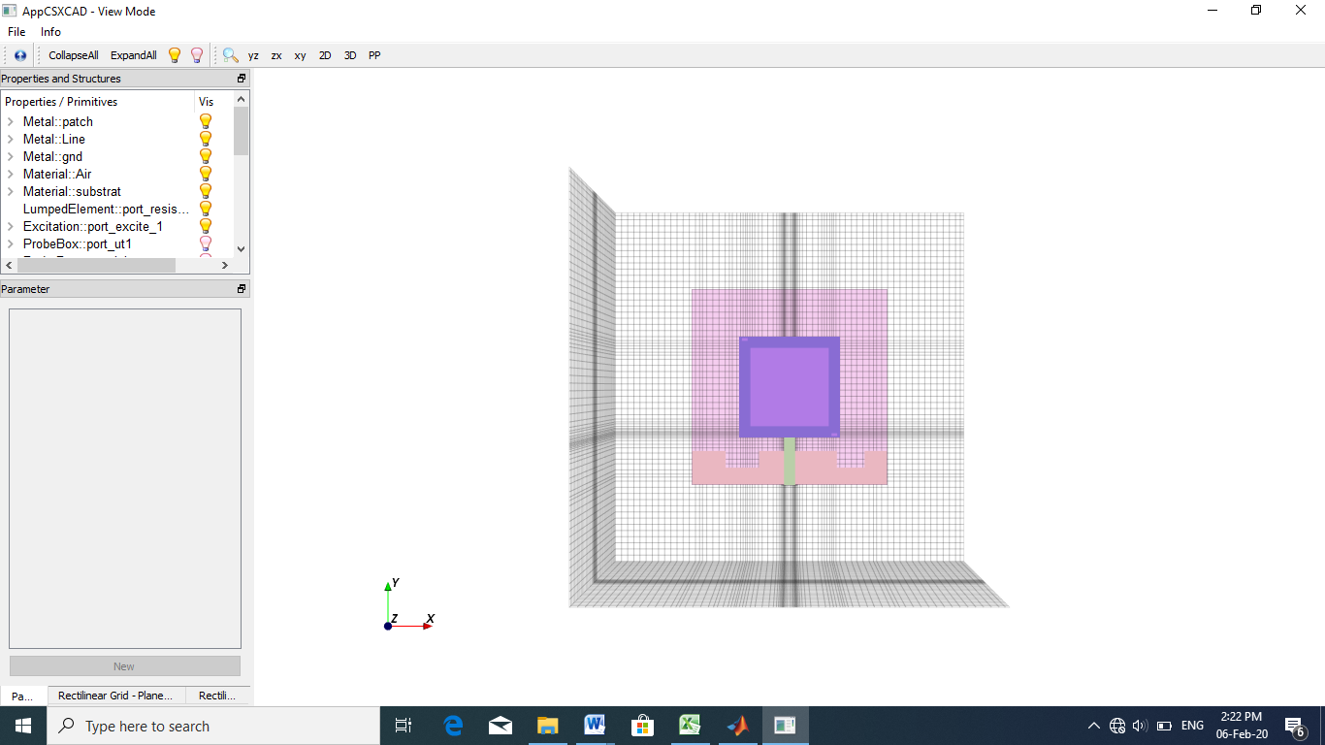
Fig. 2 Proposed antenna structure3- Results and discussions
The simulation with the FDTD technique is performed for 2510 iteration steps for this antenna model. the final return loss of the proposed antenna found from an FDTD simulation with the HFSS simulation has been plotted for comparison in Figure 3. From this comparison plot it is shown that the results of the simulation are almost equal.

Fig.3 Coefficients of reflections of the antenna proposed by HFSS AND Open EMS MATLAB
This row was calculated the FDTD method. Figure 4 represents the imaginary part and the real part of the characteristic impedance Zint in Ohms, the figure shows that the value of Zint is always almost at 50 Ohm.
Fig.4 Power point impedance
3D radiation pattern
The simulated radiation pattern at the resonant frequency of 5.2GHz is shown in Figure 5. The 3D view of the antenna radiation pattern indicates that the main beams are slightly shifted towards the y-axis. The proposed antenna has an omnidirectional radiation characteristic over the entire operating band.

Fig. 5 3D radiation pattern For f=5,2GHz
The radiation diagram in the plane 𝟇 = 0 for 5.2GHz is omnidirectional, On the other hand when 𝟇 = 90 and the diagram undergoes a considerable deformation. The maximum value of the antenna gain is 1dB.
Fig.6 2D radiation pattern

- Conclusion
In this paper, a micro-strip antenna is analyzed using the finite difference time domain (FDTD). Analyze the return loss characteristics, it shows that the antenna is a good candidate for GPS, IMAX ,WLAN applications and 5G. The result of the FDTD simulation is compared with the HFSS simulation the results are agreed satisfactory.

.

References
- Hung Loui, Student Member, IEEE 1D-FDTD using MATLAB, ECEN-6006 NUMERICAL METHODS IN PHOTONICS PROJECT-1, SEPTEMBER 2004.
- S. Sandeep (2006). Broadband Analysis of micro stripe patch antenna Using 3D FDTD – UPML. ECEN 5134 term paper ,university Colorado at boulder online available :http://sandeepkumar2006.tripod.com/FDTD3Dpatchantennapdf
- D. M. Sullivan, Electromagnetic Simulation using the FDTD Method. Piscataway, NY: IEEE Press, 2000.
- .R. R. McLeod, “Finite difference time domain class notes,” pp. 31–59,1 Sept. 2004.
- .https://openems.de/index.php/Tutorial:_Simple_Patch_Antenna.html
- https://www.opensourceimaging.org/project/open-ems-a-free-and-open-electromagnetic-field-solver/
- D. E. Merewether, R. Fisher, F. W. Smith, “On Implementing a Numeric Huygen’s Source Scheme in a Finite Difference Program to Illuminate Scattering Bodies”, IEEE Trans. Nuclear Science, vol. 27, no. 6, Dec. 1980, pp.1829-1833.
- L-C. Ma, R. Mittra, “Implementation of Gaussian Beam Sources in FDTD for Scattering Problems”, IEEE Trans. Electromagnetic Compatibility, vol. EMC-24, no. 4, Nov. 1982, pp.397-405.
- I. R. Capoglu, A. Taflove, V. Backman, “Generation of an incident focused light pulse in FDTD,” Optics Express, vol. 16, no. 23, pp. 19208–19220, Nov. 2008.
- K. Umashankar, A. Taflove, “A Novel Method to Analyze Electromagnetic Scattering of Complex Objects”, IEEE Trans. Electromagnetic Compatibility, vol. EMC-24, no. 4, Nov. 1982, pp.397-405.
- R. J. Luebbers, K. S. Kunz, M. Schneider, F. Hunsberger, “A Finite-Difference TimeDomainNear Zone to Far Zone Transformation”, IEEE Trans. Antennas and Propagation, vol. 39, no. 4, April 1991, pp.429-433.

- R. J. Luebbers, K. S. Kunz, M. Schneider, F. Hunsberger, “A Finite-Difference TimeDomainNear Zone to Far Zone Transformation”, IEEE Trans. Antennas and Propagation, vol. 39, no. 4, April 1991, pp.429-433.
- M. Celuch-Marcysiak, W. K. Gwarek, “Implicit incorporation of nonlinear elements for unconditionally stable FDTD analysis at coarse time-steps”, IEEE MTT-S International, vol. 3, June 1996, pp.1381-1384.
- M. Fujii, M. Tahara, I. Sakagami, W. Freude, P. Russer, “High-Order FDTD and Auxiliary Differential Equation Formulation of Optical Pulse Propagation in 2-D Kerr and Raman Nonlinear Dispersive Media”, IEEE Journal of Quantum Electronics, vol. 40, No.2, Feb.2004, pp.175-182.
- M. Celuch, “A method of analysis of planar circuits incorporating nonlinear elements,” M.Sc. Thesis, Warsaw University of Technology, 1988.
- F. Kung, H. T. Chuah, “A study on the stability of bipolar-junction-transistor formulation in finite-difference time-domain framework”, IEEE Trans. Microwave Theory Tech., vol. 53, No.4, April 2005, pp.1189-1196.
- A. Moryc, “Finite difference time domain electromagnetic modeling applied to dispersive and anisotropic media,” Ph.D. Thesis, Institute of Radioelectronics, Warsaw University of Technology, 2006
- L. Djouablia, "Contribution à l’étude des structures microbandes rayonnantes par la méthode des moments application à la forme triangulaire ", Soutenance de Doctorat en sciences en Electronique, Université de Constantine, Algérie, 2012
- H. Chaker, "Conception et optimisation de réseaux d’antennes imprimées a faisceaux multiples application des réseaux de neurones", Mémoire de, doctorat en télécommunications, université de Tlemcen, Algérie, 2012.
- F. Benmeddour, "Etude et réalisation d'un résonateur microruban de forme circulaire (application au cas particulier de l'alimentation par couplage)", Thèse En vue de l’obtention du diplôme de doctorat en sciences, Université de Constantine, Algérie, 2012
- Y. Tighilt, "Identification des antennes microrubans multicouches par la méthode spectrale et les réseaux de neurones ", Thèse doctorat en sciences, Université de Sétif-ufas (Algérie), 2011
- W. K. Gwarek, “Analysis of Arbitrarily Shaped Two-Dimensional Microwave Circuits by Finite-Difference Time-Domain Method”, IEEE Trans. Microwave Theory Tech., vol. 36, No.4, April 1988, pp.738-744.
- M. Celuch-Marcysiak, W. K. Gwarek, “On the nature of solutions produced by finite difference schemes in time domain”, International Journal of Numerical Modelling – Electronic Networks, Devices and Fields, vol. 12, no. 1/2, January-April 1999, pp.2340
- W. L. Ko, R. Mittra, “A Combination of FD-TD and Prony’s Methods for Analyzing Microwave Integrated Circuits”, IEEE Trans. Microwave Theory Tech., vol. 39, No. 12, Dec. 1991, pp.2176-2181.
- M. Mrozowski, “Criteria for building Prony models for time domain CAD”, Antennas and Propagat.Society Intl. Symp., vol. 4, June 1998, pp.2306-2309.
- M. Okoniewski, E. Okoniewska, M. A. Stuchly, “Three-dimensional subgridding algorithm for FDTD”, IEEE Trans. Antennas and Propagation, vol. 45, no. 3, March 1997, pp.422-429.
- F. Chebbara, „„Etude des caractéristiques de résonance et de rayonnement des antennes microbandes réalisées avec des matériaux ayant une anisotropie de type électrique et magnétique‟‟, Thèse de doctorat, université de Batna, juin 2011.

